# KidsBlock Software

Note: We take the Windows system as an example.

Download link: [www.kidsbits.net/Down/KidsBlock Desktop 1.1.3 Setup.exe](http://www.kidsbits.net/Down/KidsBlock Desktop 1.1.3 Setup.exe)

1. Double click“KidsBlock 1.1.3 Setup.exe”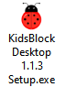.
2. Then click“More info”then“Run anyway”.

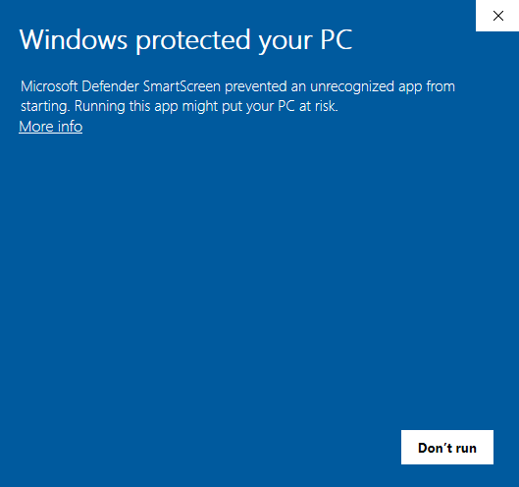

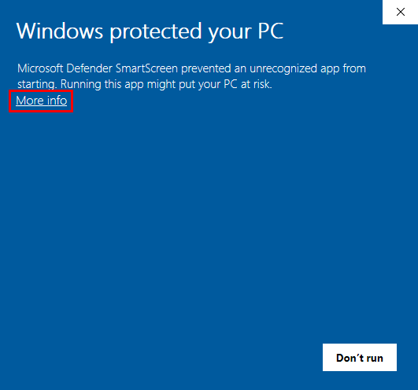

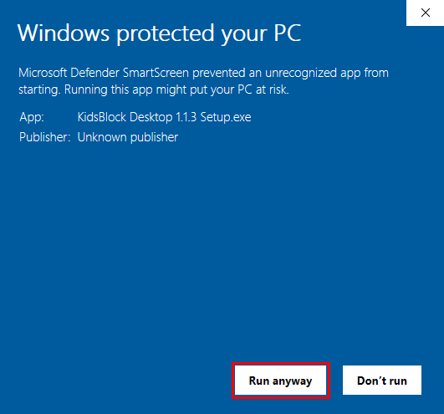

Click“**Anyone who uses this computer(all users)**”and click“**Next**”

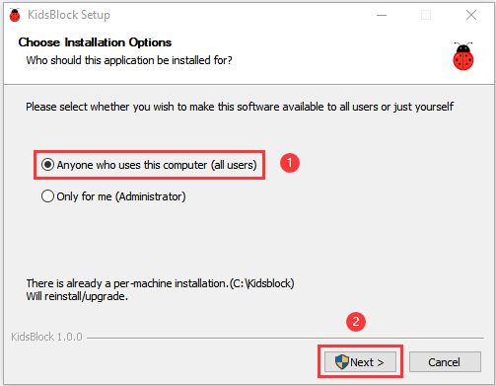

1. Click“**Browse...**”and choose the Disk where the software will be placed (here, we choose C Drive). Then click“**Install**”.

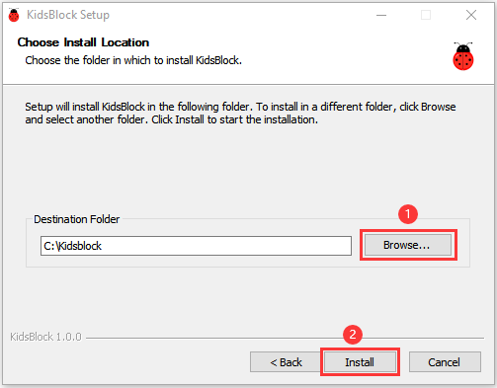

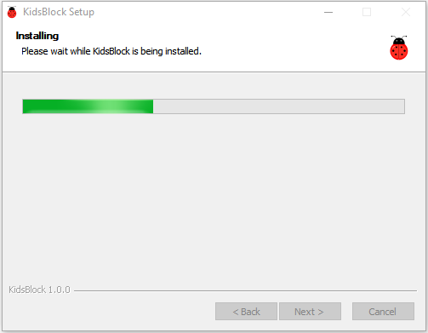

1. After a few seconds, the installation is complete.

Click "Finish" to open the installed Kidsblock software.

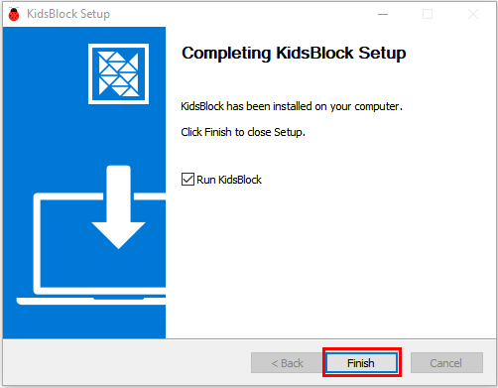

1. If the computer security alert window appears, click **Upgrade and restart** to update the latest version of the KidsBlock

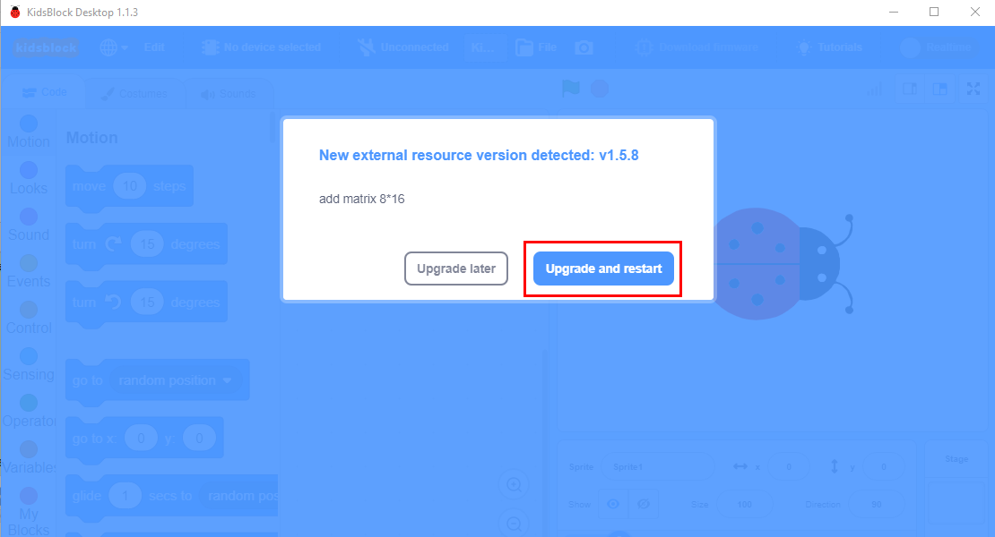

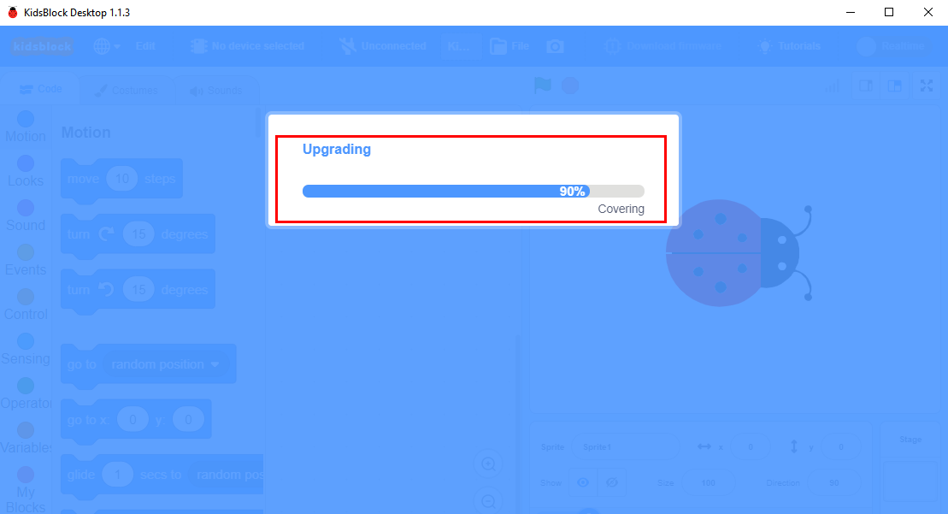

Then open Kidsblock. And click **Allow access**

